**How to Use this Template**

1. Create a new document, and copy and paste the text from this template into your new document [ Select All → Copy → Paste into new document ]
2. Name your document file: “**Capstone_Stage1**”

Replace the text in green

Description

Intended User

Features

User Interface Mocks

Screen 1

Screen 2

Screen 3

Key Considerations

How will your app handle data persistence?

Describe any corner cases in the UX.

Describe any libraries you’ll be using and share your reasoning for including them.

Describe how you will implement Google Play Services.

Next Steps: Required Tasks

Task 1: Project Setup

Task 2: Implement UI for Each Activity and Fragment

Task 3:FAB button actions

# **GitHub Username**: FlorinBacu

# NewMovies

# Description

This is a app that show recent movie from moma.org

# Intended User

This is intented for showing latest movie for people

# Features

* Display articles
* Show details about article

# User Interface Mocks

## Screen 1

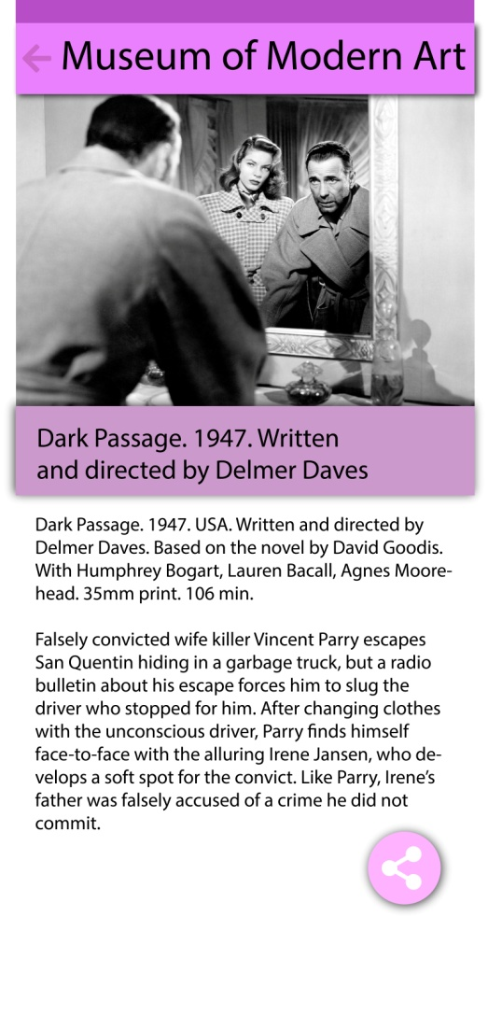

This is the detail on mobile app fab button is for sharing

## Screen 2

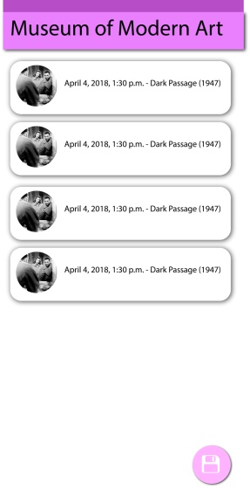

Fab button save list in database on mobile for offline loading

## Screen 3

## Table master.jpg

This is are master detail on tablet

# Key Considerations

### 

### How will your app handle data persistence?

A snapshot of data will be saved in database by using FAB button

### Describe any edge or corner cases in the UX.

For example, how does the user return to a Now Playing screen in a media player if they hit the back button?

### Describe any libraries you’ll be using and share your reasoning for including them.

I use Piccasso for my images and butterknife for code simplication and Tinker for console log.

### Describe how you will implement Google Play Services or other external services.

The external service is on link <https://www.moma.org/feeds/events_films_30_days.rss>

Using a XML parser

# Next Steps: Required Tasks

This is the section where you can take the main features of your app (declared above) and break them down into tangible technical tasks that you can complete one at a time until you have a finished app.

## Task 1: Project Setup

The project setup using a thread using async task loader to load data.

You may want to list the subtasks. For example:

* Configure libraries
* Load rss data via web

If it helps, imagine you are describing these tasks to a friend who wants to follow along and build this app with you.

## Task 2: Implement UI for Each Activity and Fragment

List the subtasks. For example:

* Build UI for MainActivity
* Build UI for Detail activity

## Task 3: FAB button actions

FAB Action on main activity have save button for saving data in database and other for sharing

Describe the next task. List the subtasks. For example:

* Save in db
* Share detail from a selected item

**Submission Instructions**

* After you’ve completed all the sections, download this document as a PDF [ File → Download as PDF ]
  + Make sure the PDF is named “**Capstone_Stage1.pdf**”
* Submit the PDF as a zip or in a GitHub project repo using the project submission portal

If using GitHub:

* Create a new GitHub repo for the capstone. Name it “**Capstone Project**”
* Add this document to your repo. Make sure it’s named “**Capstone_Stage1.pdf**”